# 使用通知来出发AWS Lambda

## 实验介绍

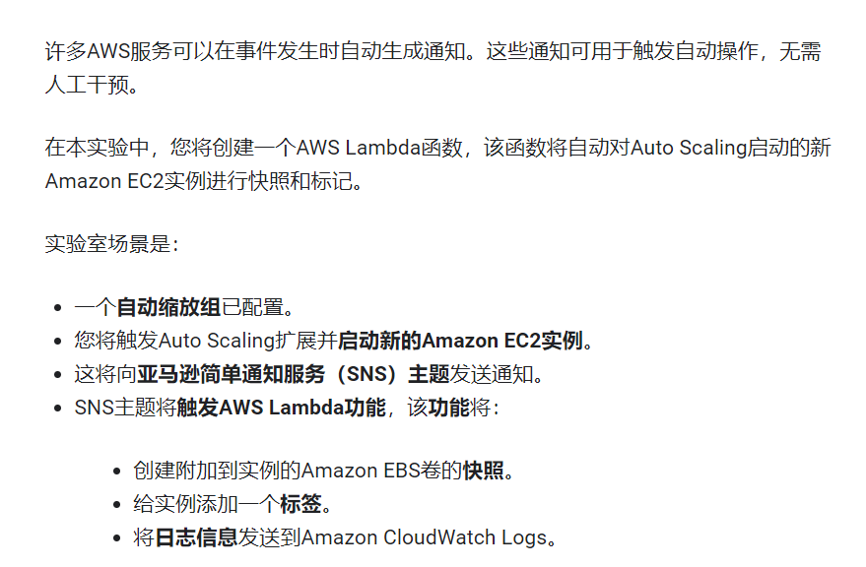

## 架构图

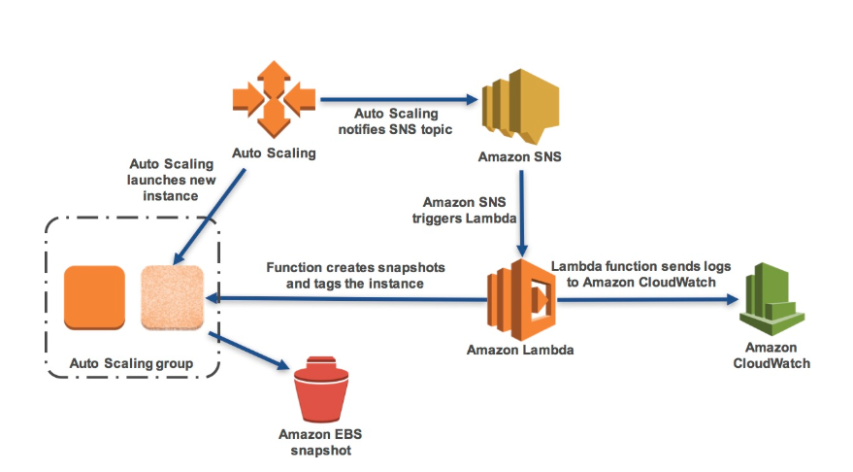

## 目标

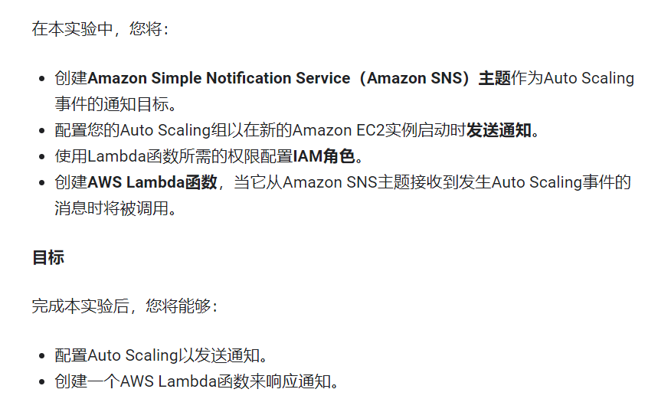

## 任务1

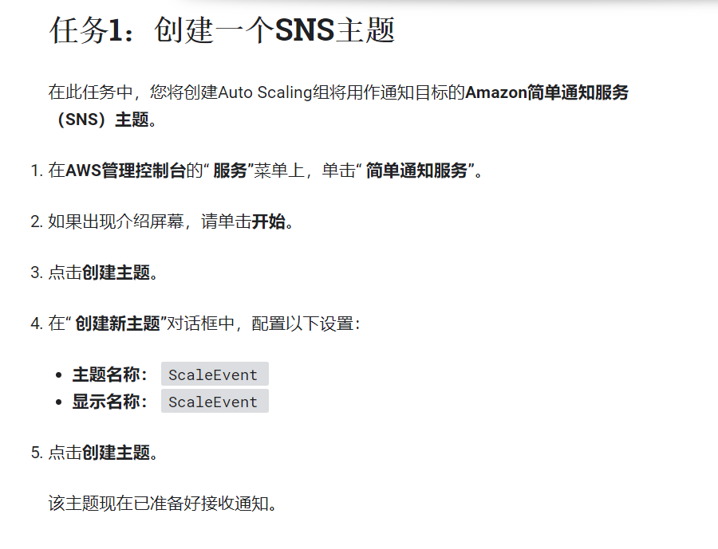

## 任务2

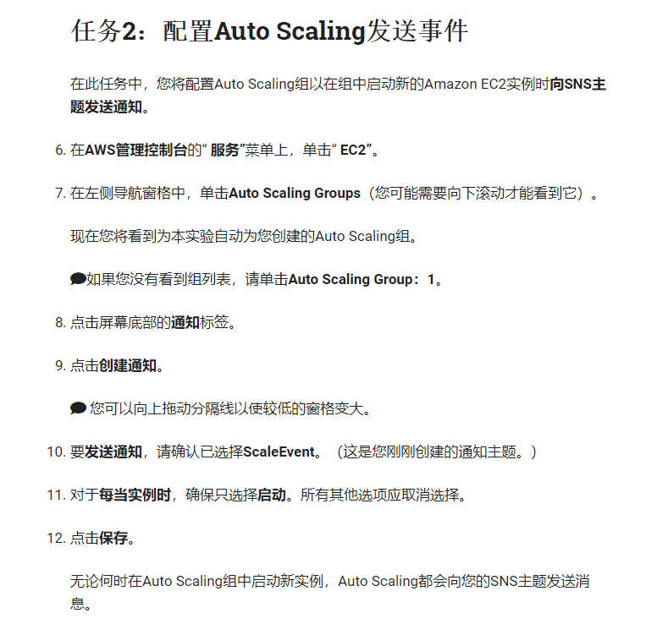

## 任务3

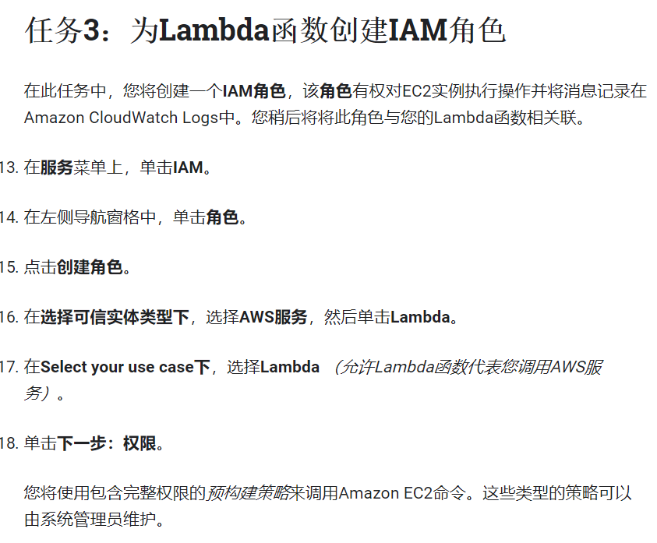

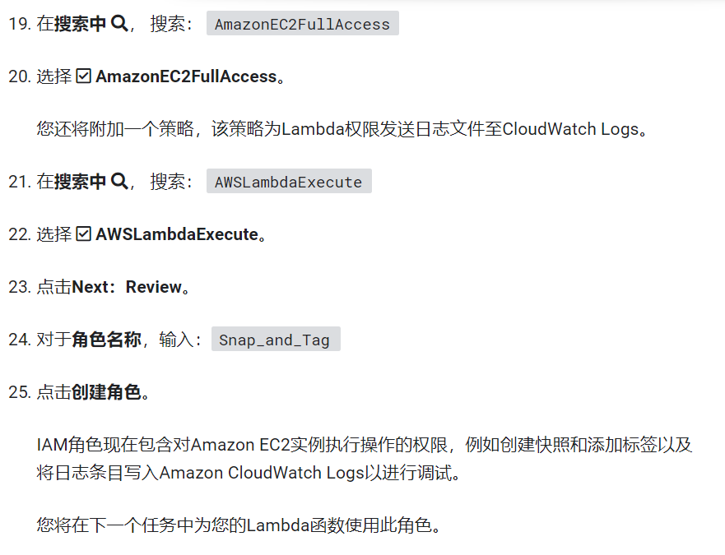

## 任务4

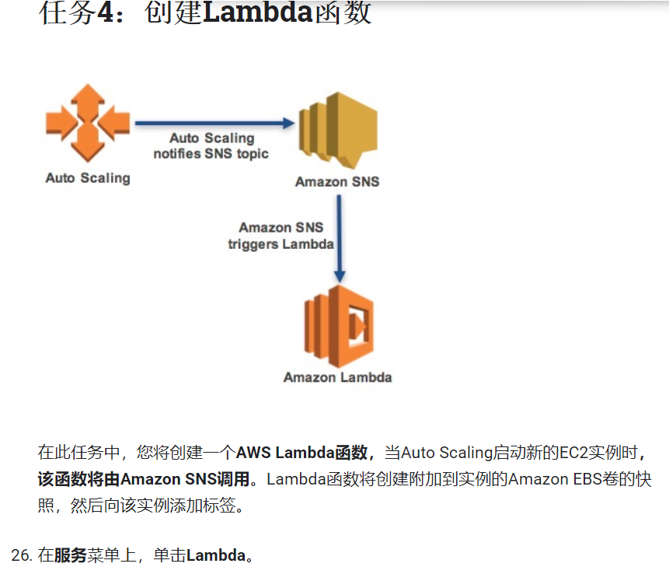

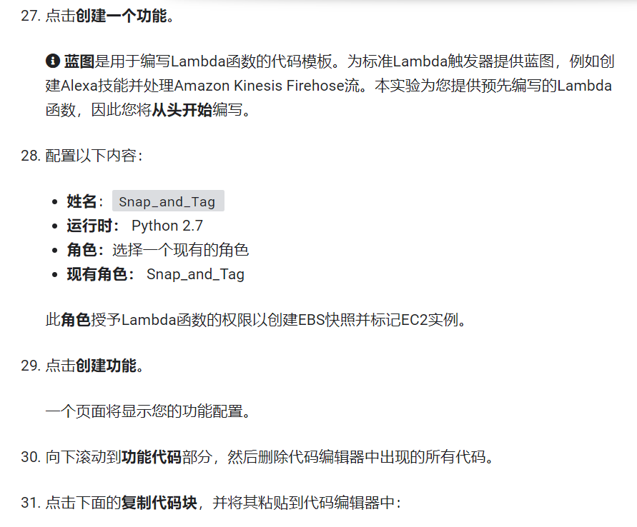

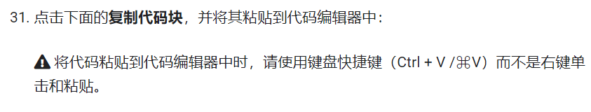

# Snap_and_Tag Lambda function

#

# This function is triggered when Auto Scaling launches a new instance.

# A snapshot of EBS volumes will be created and a tag will be added.

from __future__ import print_function

import json, boto3

def lambda_handler(event, context):

print("Received event: " + json.dumps(event, indent=2))

# Extract the EC2 instance ID from the Auto Scaling event notification

message = event['Records'][0]['Sns']['Message']

autoscalingInfo = json.loads(message)

ec2InstanceId = autoscalingInfo['EC2InstanceId']

# Snapshot all EBS volumes attached to the instance

ec2 = boto3.resource('ec2')

for v in ec2.volumes.filter(Filters=[{'Name': 'attachment.instance-id', 'Values': [ec2InstanceId]}]):

description = 'Autosnap-%s-%s' % ( ec2InstanceId, v.volume_id )

if v.create_snapshot(Description = description):

print("\t\tSnapshot created with description [%s]" % description)

# Add a tag to the EC2 instance: Key = Snapshots, Value = Created

ec2 = boto3.client('ec2')

response = ec2.create_tags(

Resources=[ec2InstanceId],

Tags=[{'Key': 'Snapshots', 'Value': 'Created'}]

)

print ("***Tag added to EC2 instance with id: " + ec2InstanceId)

# Finished!

return ec2InstanceId

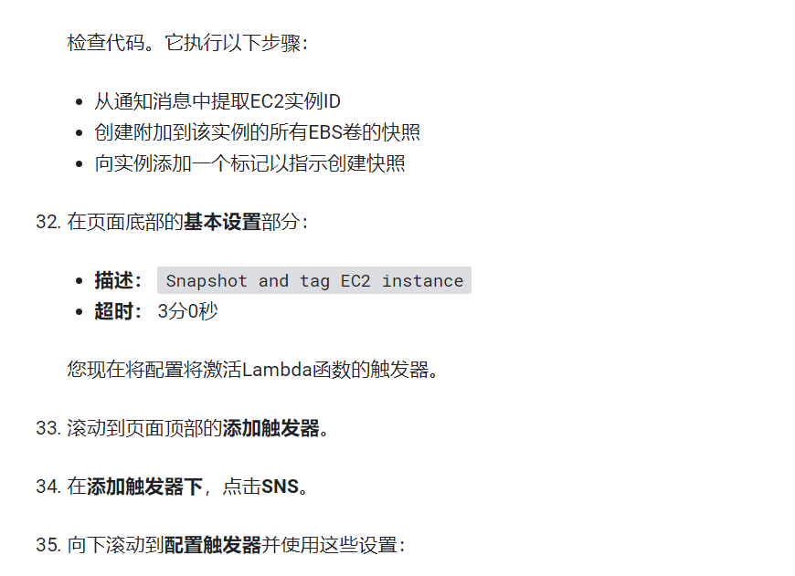

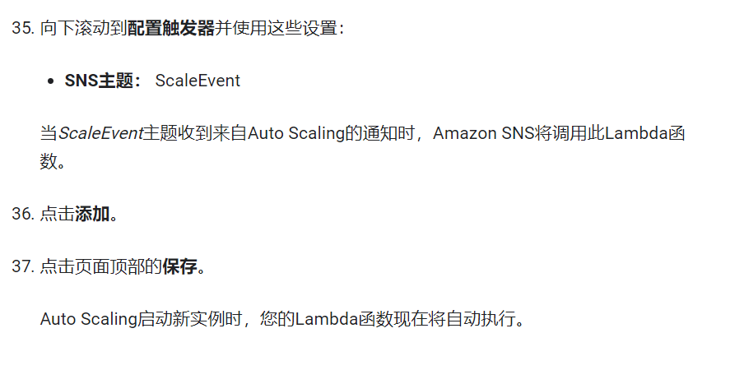

## 任务5

